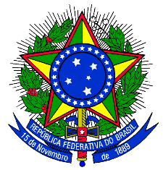

FEDERAL REPUBLIC OF BRAZIL
MINISTRY OF EDUCATION
FEDERAL UNIVERSITY OF CAMPINA GRANDE

DIPLOMA

The Rector of the Federal University of Campina Grande, by the powers legally vested in him and in acknowledgment of the completion of studies in the undergraduate program of NOME DO CURSO EM INGLÊS on data completa, and graduation ceremony held on data completa, hereby confers the title of BACHELOR OF NOME DO CURSO/PROFISSÃO upon NOME DO/A GRADUADO/A of Nacionalidade nationality, born on data completa in the city of Cidade (State of ESTADO POR EXTENSO), bearer of the national identification number no. NÚMERO – ÓRGÃO/SIGLA DO ESTADO, and grants the graduate this Diploma for the full exercise of his/her legal rights and prerogatives set forth in the current legislation.

Campina Grande, data completa.

[Signature]
Diploma Holder

Viviane Gomes de Ceballos
Provost for Undergraduate Studies

Antônio Fernandes Filho
Rector

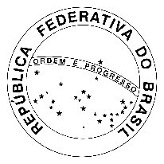
MINISTRY OF EDUCATION
FEDERAL UNIVERSITY OF CAMPINA GRANDE
DEAN´S OFFICE FOR TEACHING AFFAIRS
ACADEMIC CONTROL COORDINATION

Ministry of Education
CNPJ: 00.394.445/0003-65
Federal University of Campina Grande
CNPJ 05.055.128/0001-76
Accreditation renewed by the Ministerial Order no. 40/SERES/MEC from January 21, 2013, DOU no. 16 Section 1, Page 5, from January 23, 2013.

Undergraduate Program: Nome do curso em inglês
Campus: Nome do campus
Renewal of the recognition: Ministerial Order no. (NÚMERO)/(ANO)-SERES/MEC, on (DAY/MONTH/YEAR), DOU no. (NÚMERO), Section (NÚMERO), Page (NÚMERO), on (DD/MONTH/YEAR).

Diploma registered under the No. XXXX, book UFCG-X, page XXXX, by delegation of responsibilities from the Ministry of Education, under the terms of Law no. 9.394, of December 20, 1996, and from Decree no. 9.235, of December 15, 2017.

Process no. 23096.XXXXXX/2022-XX

Campina Grande, data completa.

[signature]
Name
Coordinator of Diplomas Registration
Ordinance R/SRH no. 286 from 10/02/2009
[signature]
Name
Coordinator of Academic Control

I certify that the translation corresponds to the original text.

(signature)
Verônica Macário de Oliveira
Advisor for International Affairs
Federal University of Campina Grande

